# **Evidence Log**

# Definition of Done

A user story is done when:

The user story meets a need of the Client

The user story implementation meets all the acceptance criteria.

Each acceptance criteria has at least one test case associated with it.

The team has written and completed the tests which have passed.

Any configurations needed to be performed to deploy the user story to production are recorded.

# Planning

To understand the requirements of the project better, the first thing we did was create visual representations of the project. It identified the users (except for administrator) and the requirements that performed key functionality. Creating a visual snapshot of the project allowed the team to quickly understand the main project requirements.

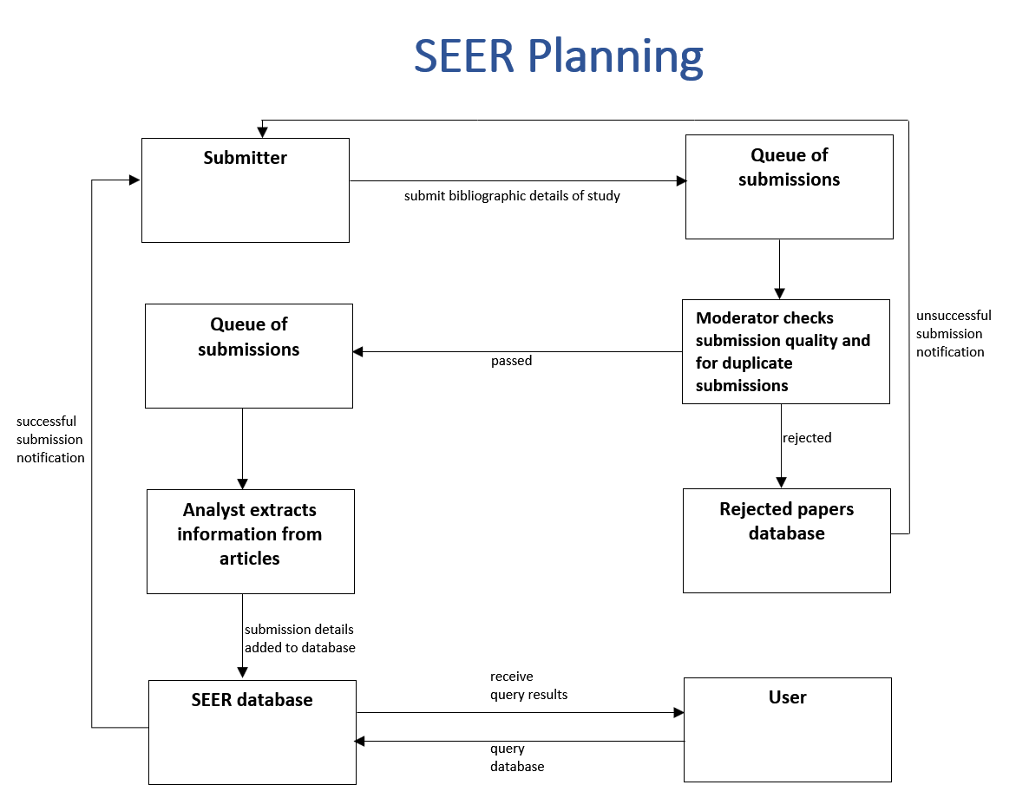

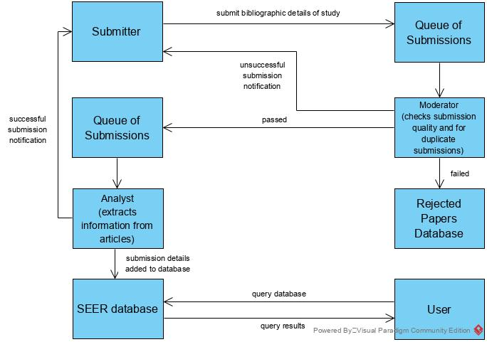

# A screenshot of a computer Description automatically generatedSprint 1 Burndown Chart

## Analysis

Our team underestimated the amount of time it would take to set up our development environment. It took us over a week to setup GitHub, Gitflow, Heroku, Trello and create user stories. During the first week Justin and James left a group of 4 people, formed a group of 2 people and then had Zane join us. Re-forming teams put us a few days further behind. We completed our couple of user stories during this sprint, however our slow start will increase the workload and pressure on our remaining sprints.

# Meetings

# **TEAM MEETING MINUTES**

| **Project Name:** | Assignment 1B | **Project:** | SEER |
| --- | --- | --- | --- |
| **Date of Meeting:** | 28/5/20 | **Time:** | 7:00pm |
| **Meeting Facilitator:** | James | **Location:** | Microsoft Teams |

|  |  |  |  |  |  |  |  |  |  |  |
| --- | --- | --- | --- | --- | --- | --- | --- | --- | --- | --- |
| 1. Meeting Objective | | | | | | | | | | |
| Discuss progress made since last meeting, any ideas we have had and what we want to have done before the next meeting. Ideally finsh a page to display search results. | | | | | | | | | | |
| 2. Attendees | | | | | | | | | | |
| **Name** | | **Role** | | | **Email** | | | | **Phone** | |
| Justin Yueng | | Team Member | | | fbb3628@autuni.ac.nz | | | | 021 786 4567 | |
| James Eason | | Team Member | | | jameas03@autuni.ac.nz | | | | 021 139 7315 | |
| Zane | | Team Member | | | dtm0650@autuni.ac.nz | | | | 021 456 6578 | |
| 3. Meeting Agenda / Notes / Decisions / Issues | | | | | | | | | | |
| **Topic** | | | | | | | **Owner** | | | **Time** |
| **Progress**  Search form, connected database to search form, display search results, organise search results e.g. date in ascending order | | | | | | | all | | | 7:00pm |
| **Ideas**  Analyst should have a button that finds similar articles in the rejected articles database as submissions for the same article will not be exactly the same i.e. one may more more whitespace. | | | | | | | all | | | 7:10pm |
| **Goal**  Search results page, unit tests, continuious integration | | | | | | | all | | | 7:20pm |
| **Next week: testing and quality assurance** | | | | | | |  | | |  |
| 4. Action Items | | | | | | | | | | |
| **Action** | | | | | | | **Owner** | | | **Due Date** |
| **Documentation**  Describe screen shots  **Website**  2 conditional search query  Buttons: check, reject, approve  Check: shows similar articles | | | | | | | Justin | | | 30/5/30 |
| **Documentation**  Learning report: sections 1a, 1b, 1c  Buttons on analyst page | | | | | | | James | | | 30/5/30 |
| **Domumenation**  Evidence log sections | | | | | | | Zane | | | 30/5/30 |
| 6. Next Meeting | | | | | | | | | | |
| **Date:** | 31/5/2020 | | **Time:** | 7:00pm | | **Location:** | | Microsoft Teams | | |
| Objective: | Discuss analyst page and begin work on testing | | | | | | | | | |

# Sprint 1 Review

Attendees: James, Justin, Zane, Peter, Jim

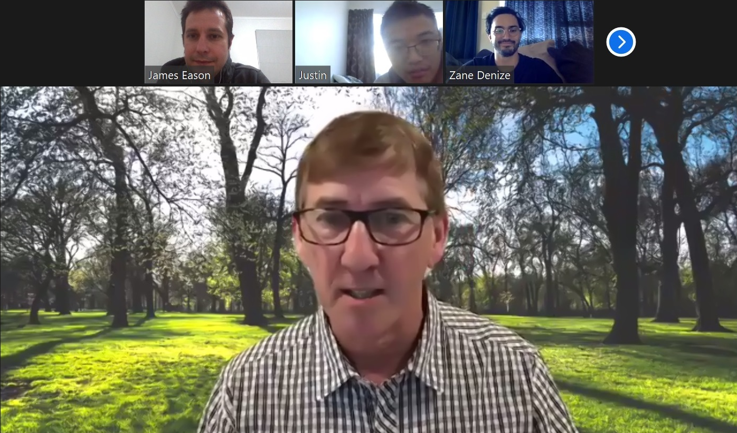We verified the project scope with Peter and discussed when we should focus on in the next sprint with Jim.

# Planning Meeting

We made a list of web pages that we would need to create which helped us in writing user stories. index.html  
userSearch.php  
userSearchResults.php  
analyst.php  
submitarticle.php

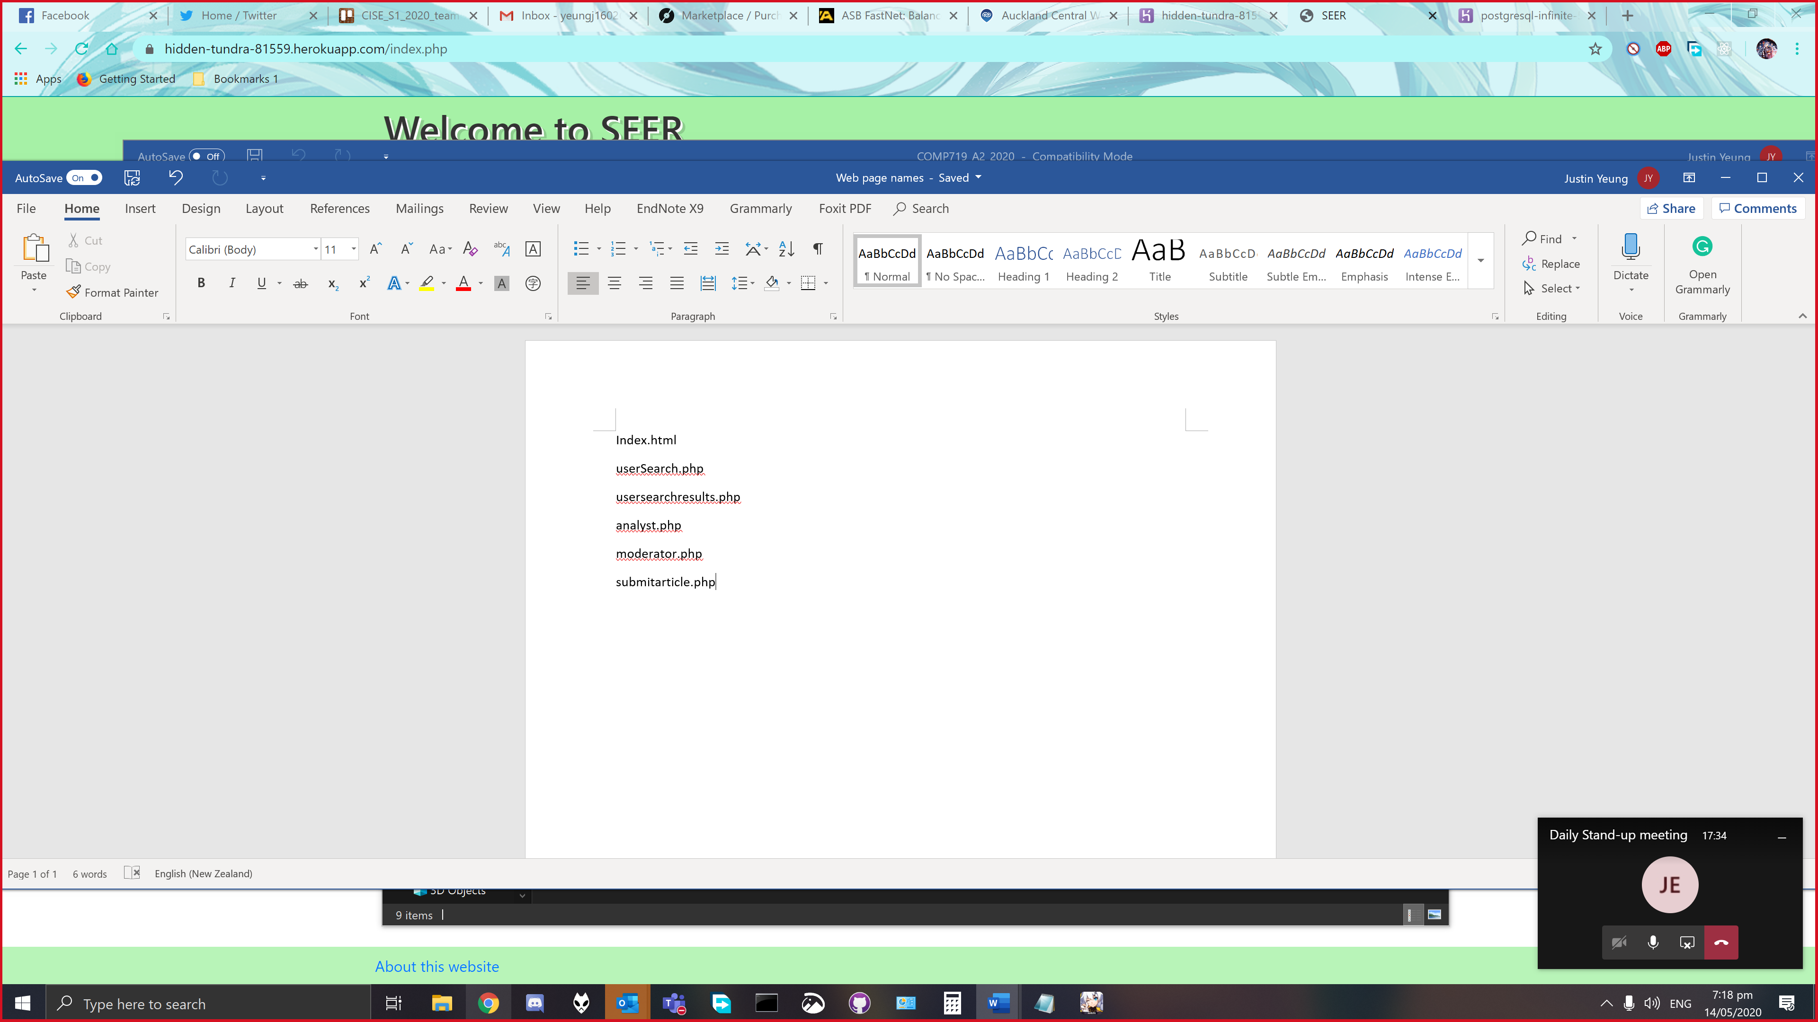

# Database

Justin created our team database on Heroku.

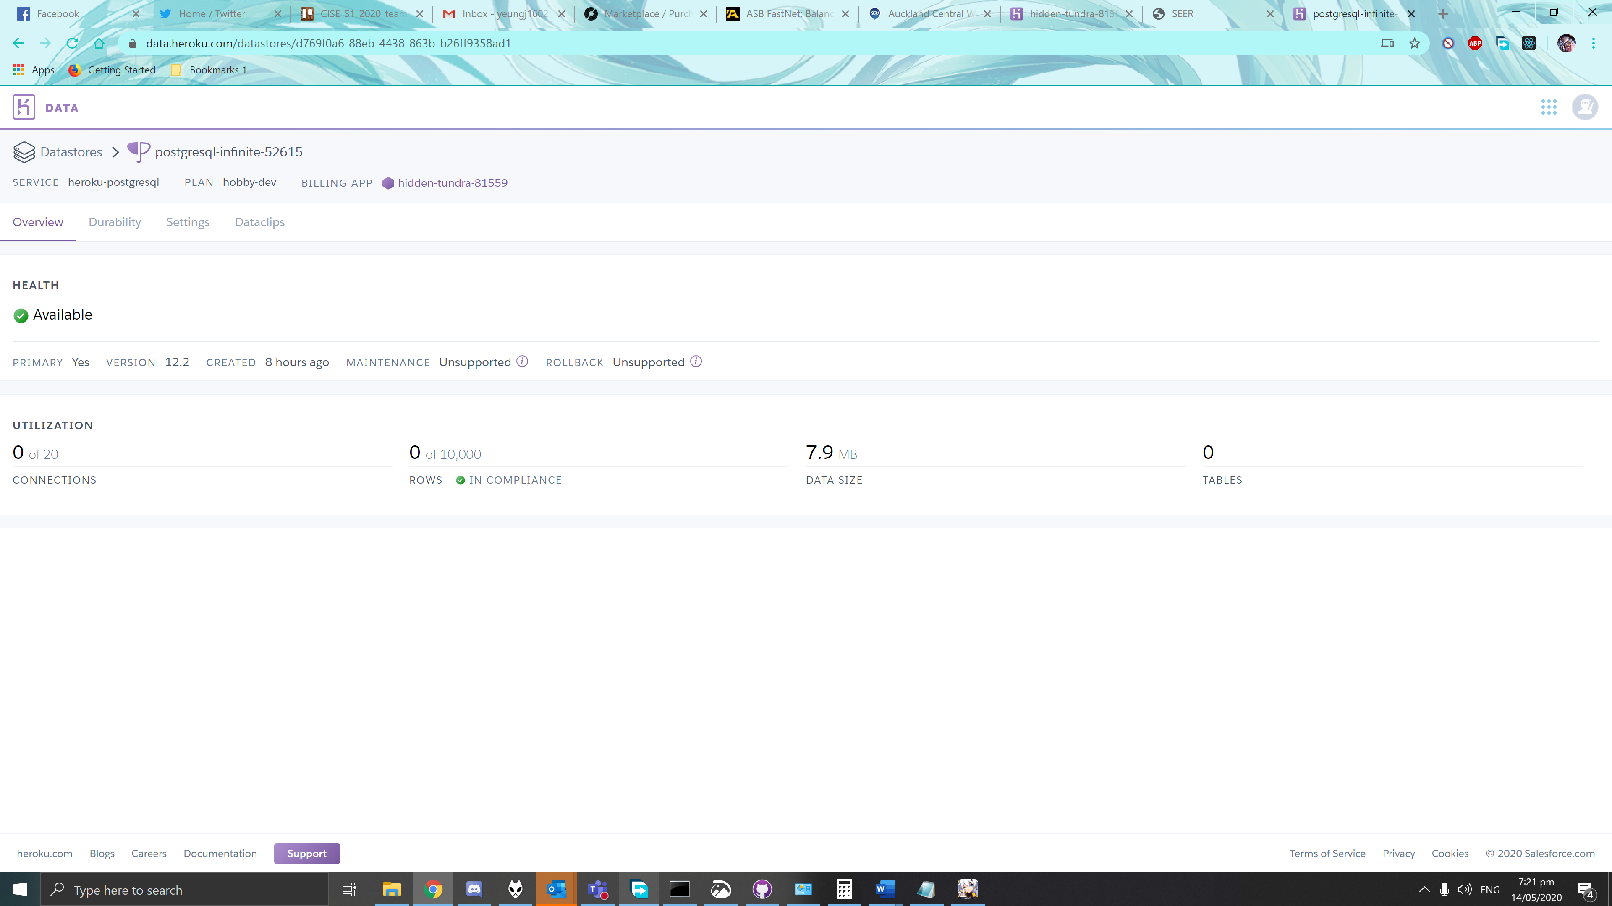

# Changing Development

Initially we planned to create the SEER system using bootstrap. We quickly realised that in doing so we would run out of time and be unable to complete the project. We decided to go for default browser styling, which meant less time spent coding on the pages look and feel. We think we can still make a good website that performs well if our page layout and styling is neat and tidy.

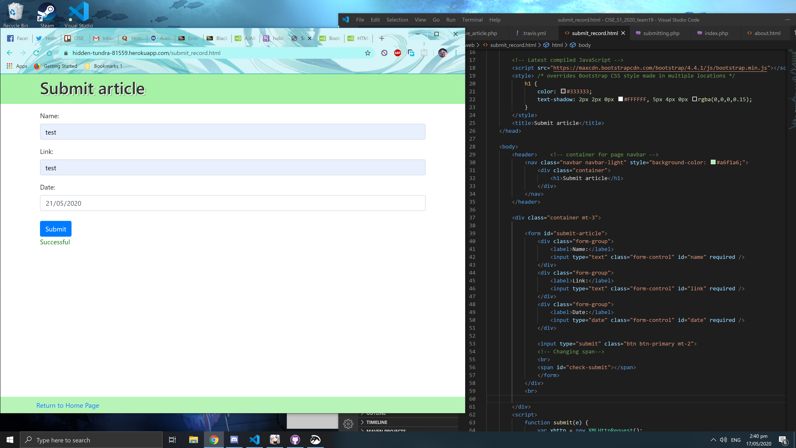

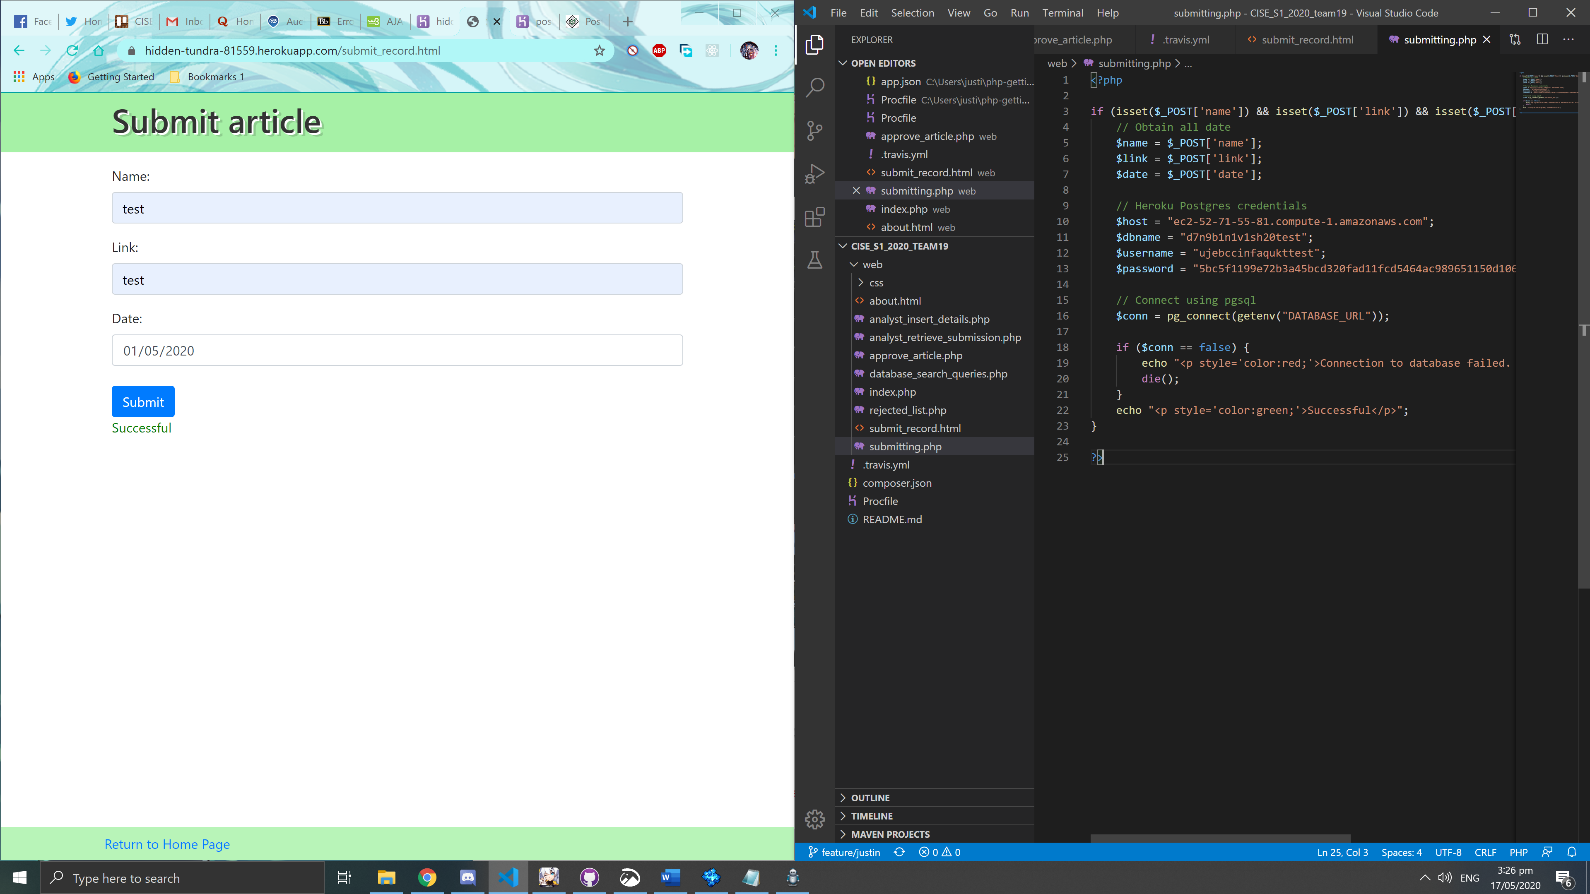

Connected to database using pgsql. Looks like credentials were not needed, just the environmental variable.

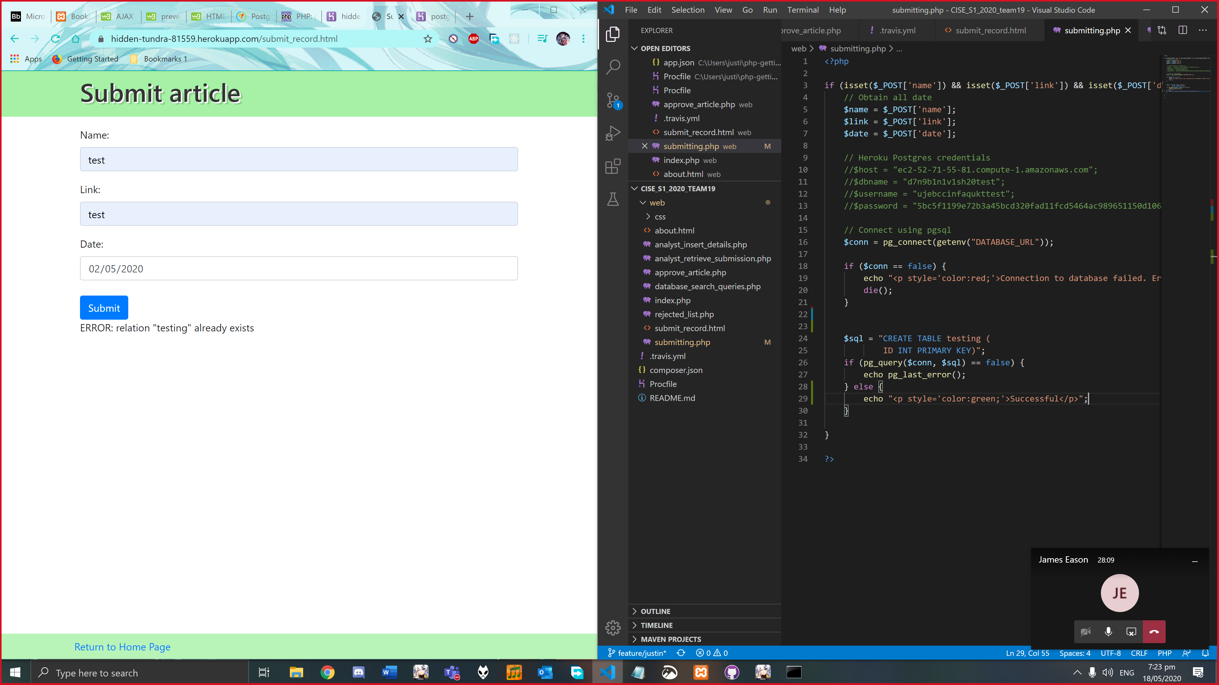

Made the SQL queries work, the table is already created as shown below

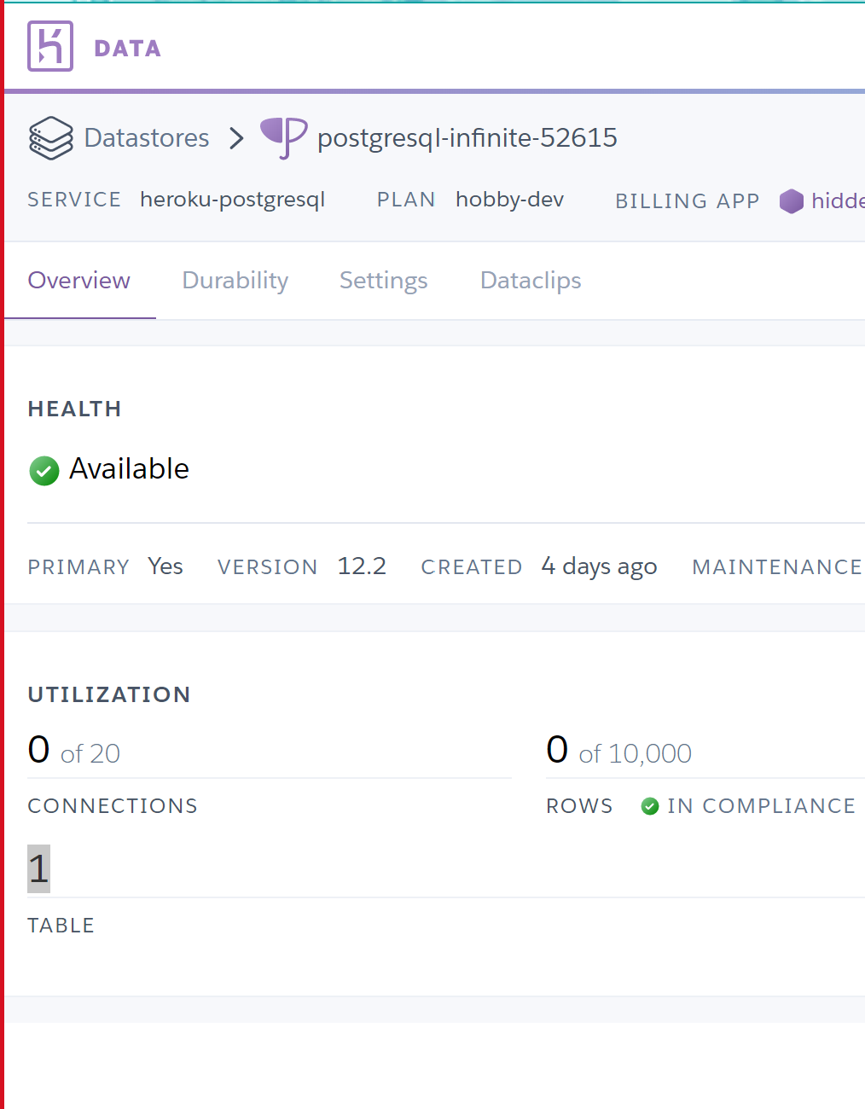

I’ve managed to create a table in Heroku postgresql

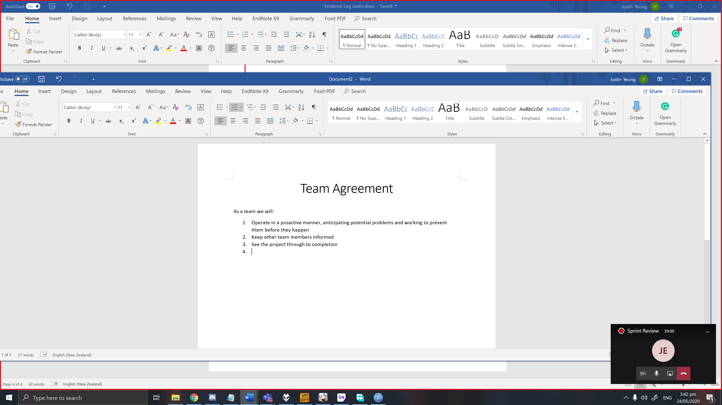

Creating team agreement.

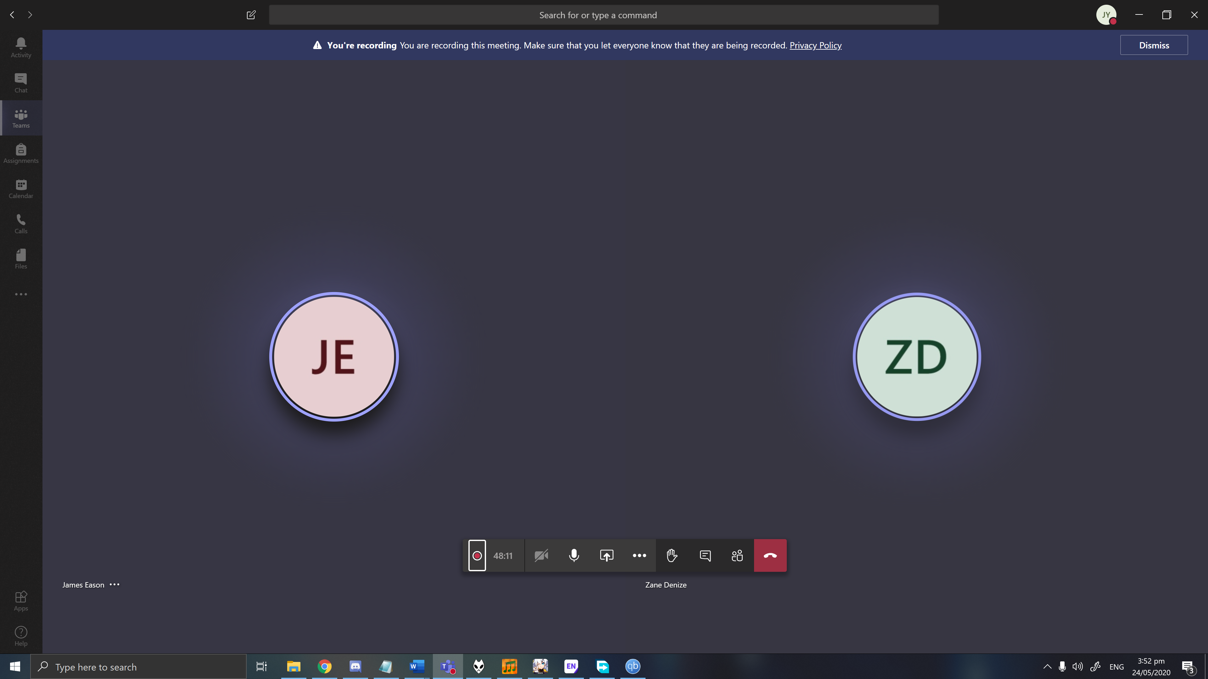

Our Sprint Review 24/05/20. 46 Minutes

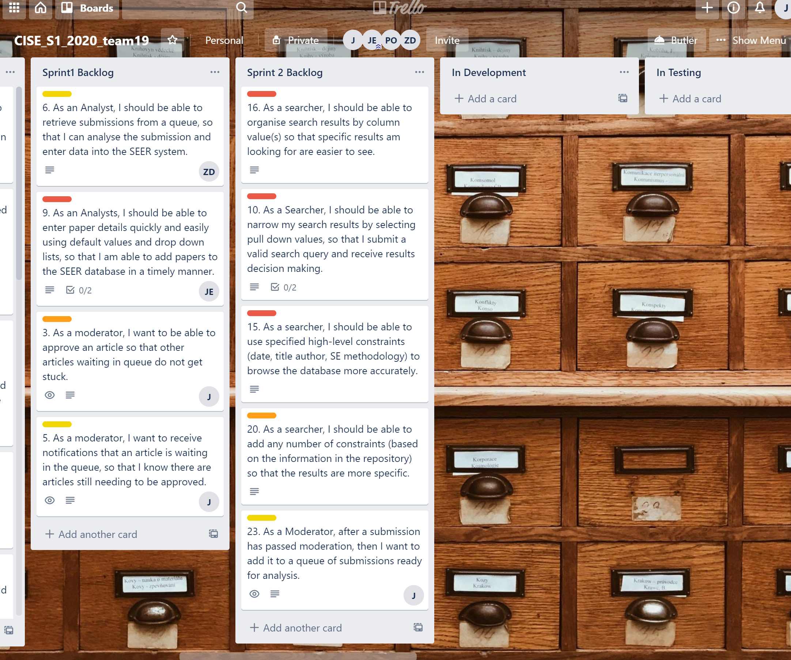

Created Sprint 2 List and put PO’s priority user stories in there.

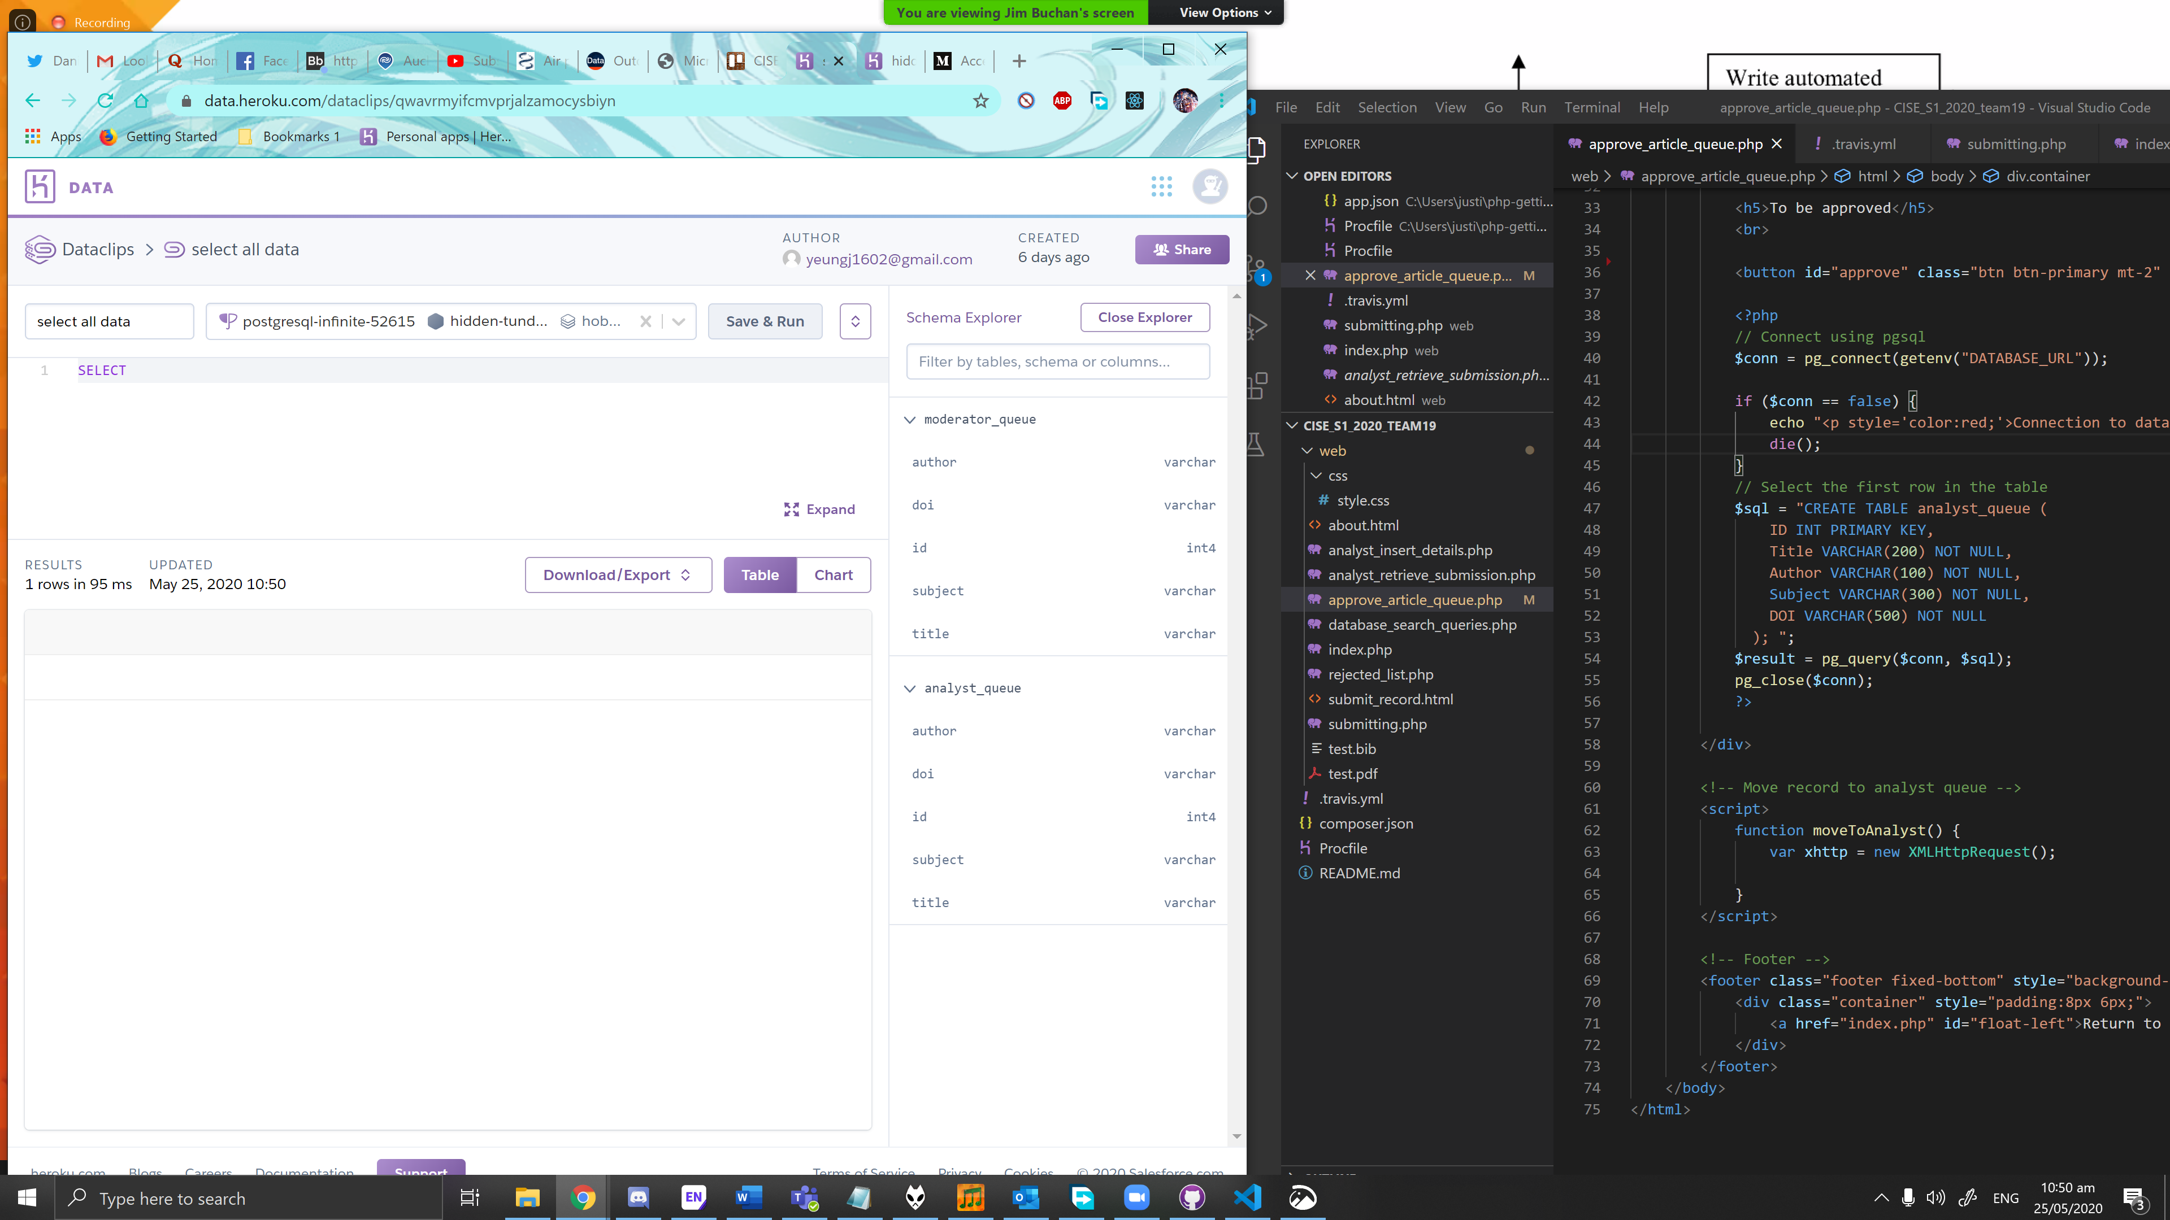

Created two tables for moderator queue and analyst queue using php.

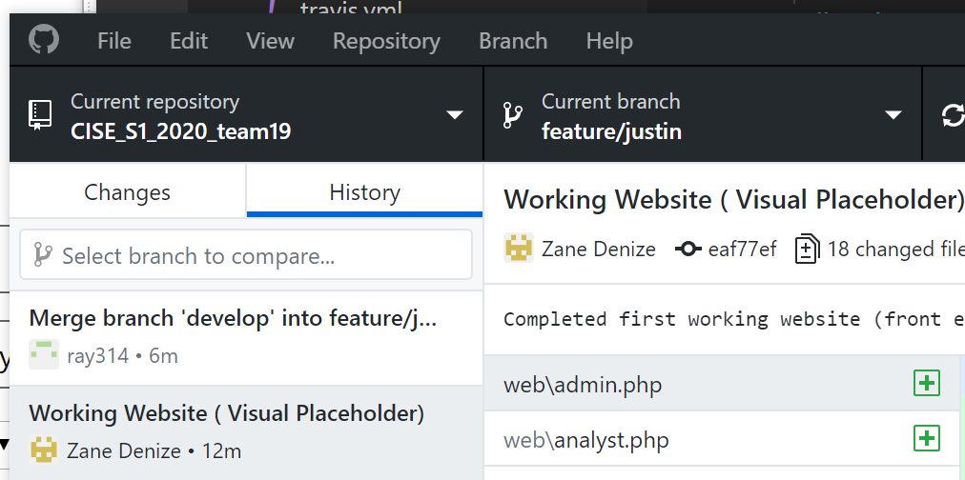

Merged Zane’s branch into develop then I merged develop into my branch.

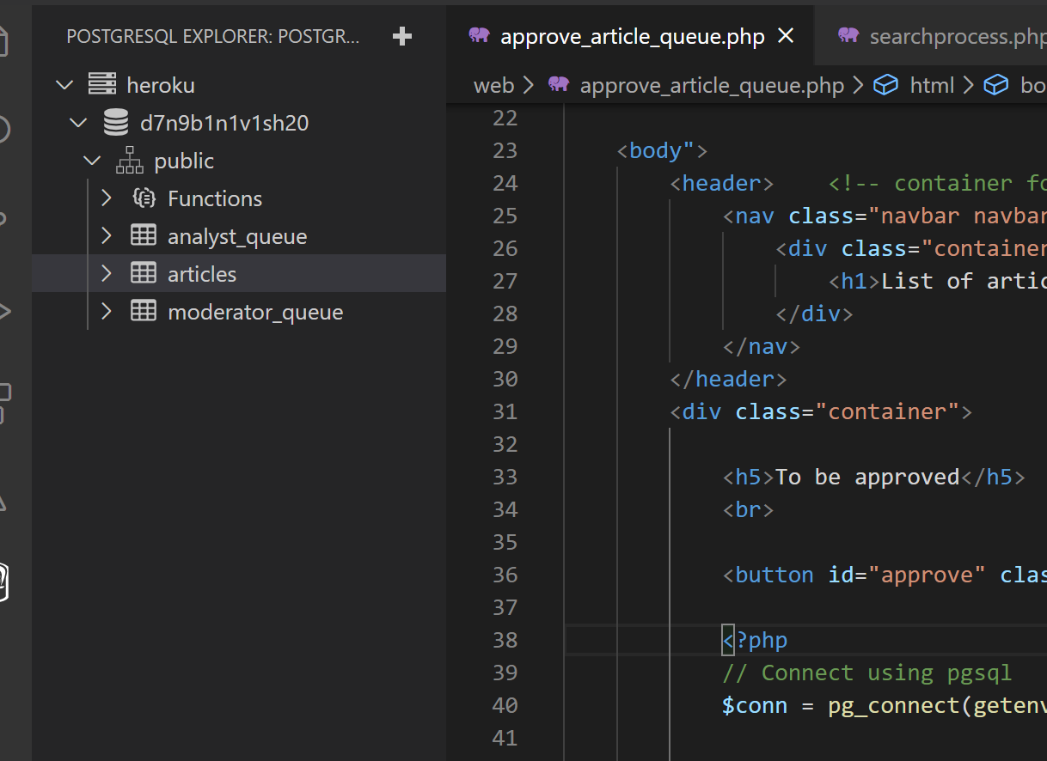

Created a table for articles that have been compiled by analysts. Also using the Postgresql extension for VS code to execute queries and view the database

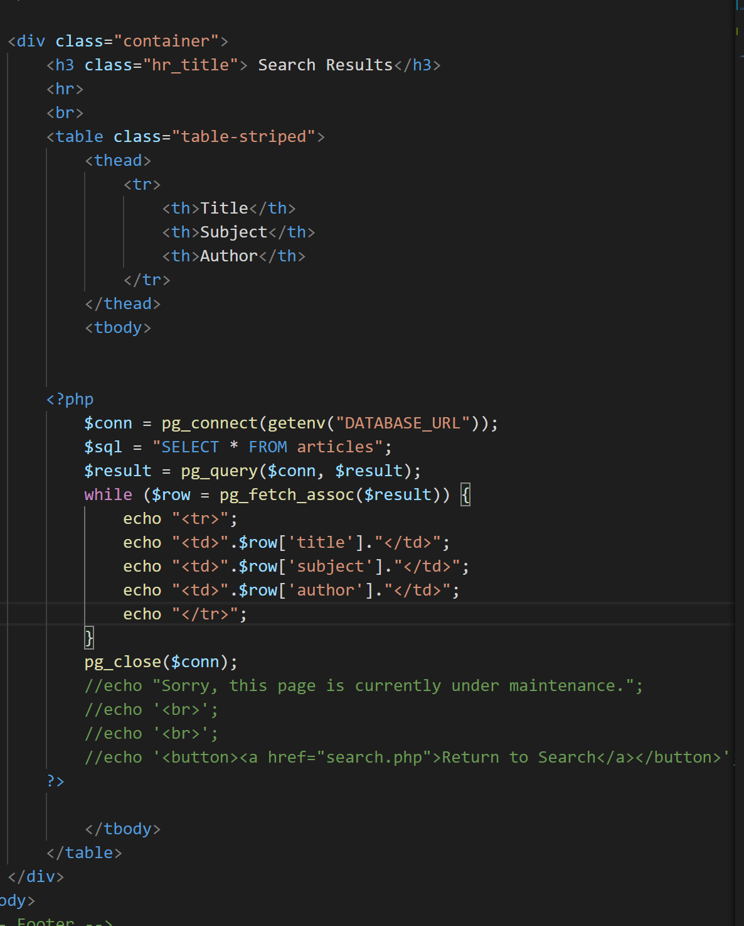

Creating a table for the search results

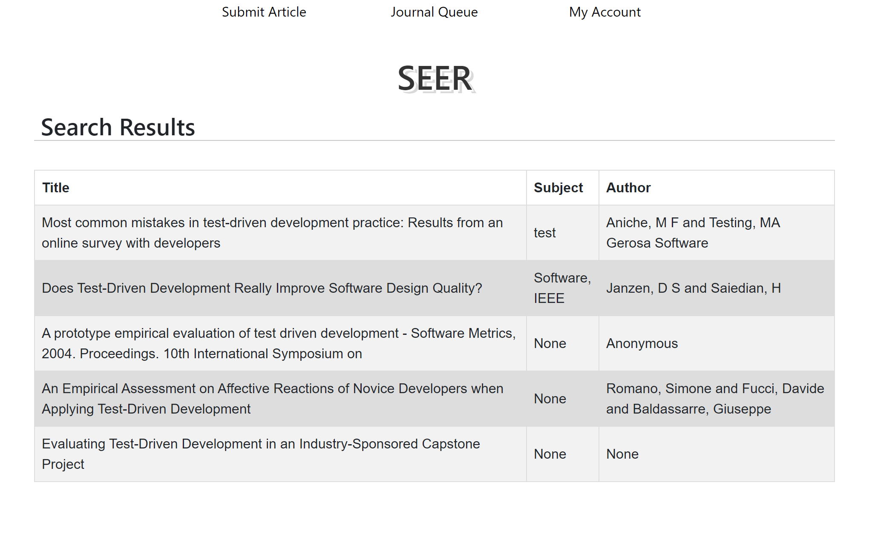

Made the page display all results in articles table

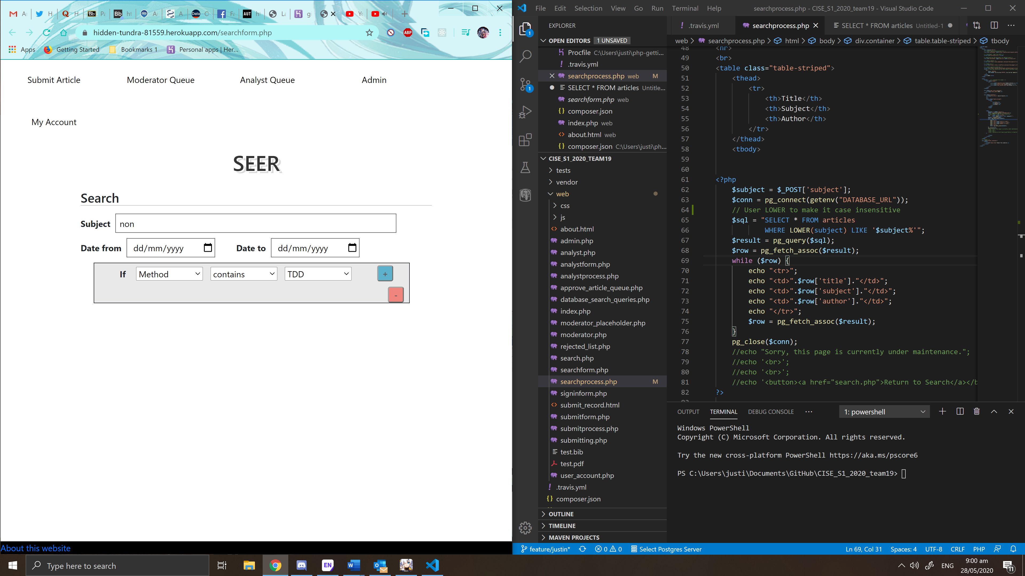

I have included LIKE conditional in SQL query for subject. Also used LOWER so it is case insensitive

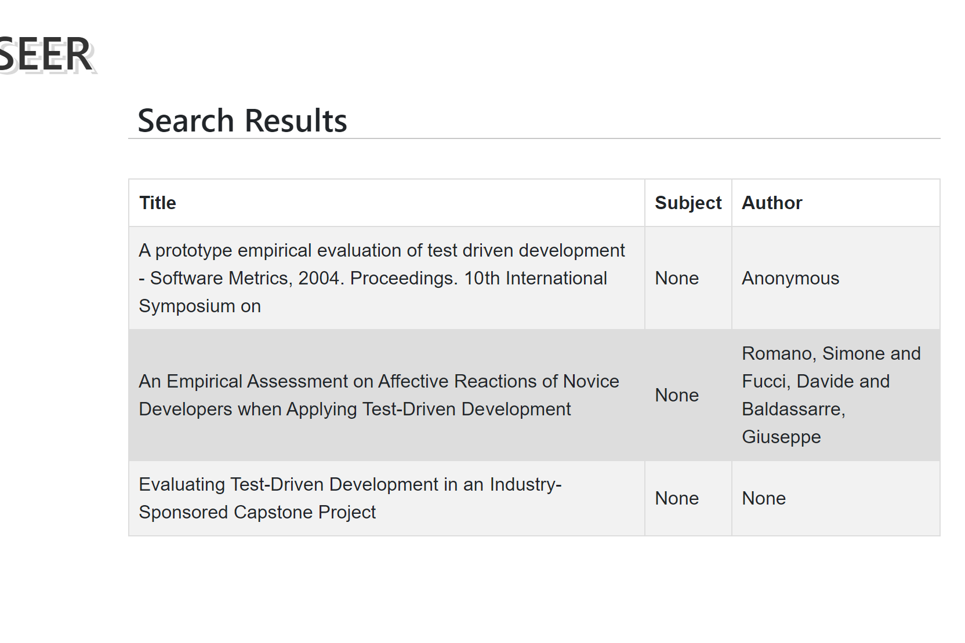

On the subject column, only None subjects are shown

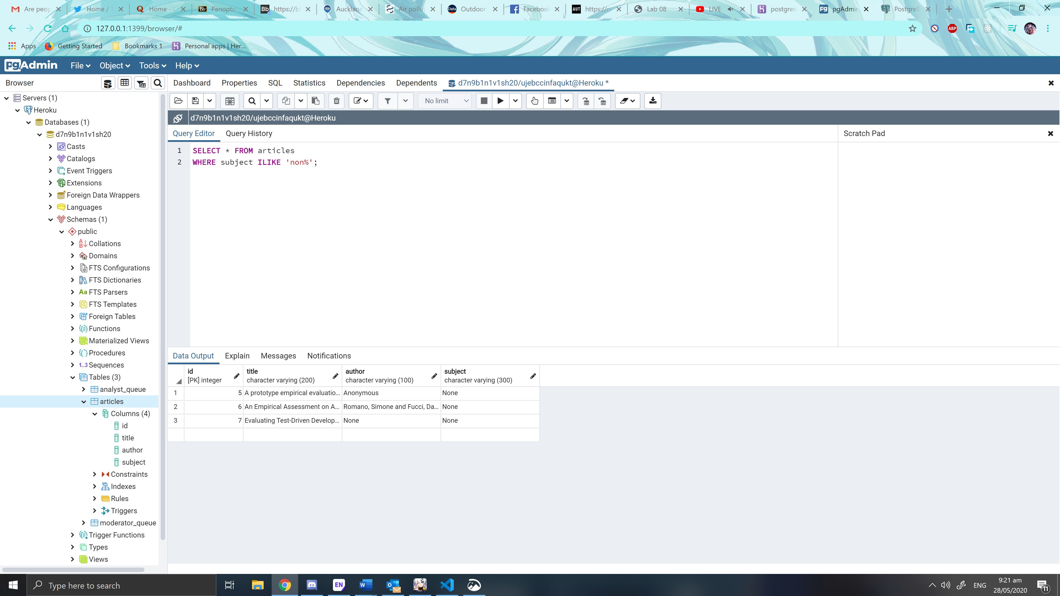

Using pgadmin 4, it feels so much better to have a GUI to manage my database. Also I have used ILIKE instead of lower since it works the same way

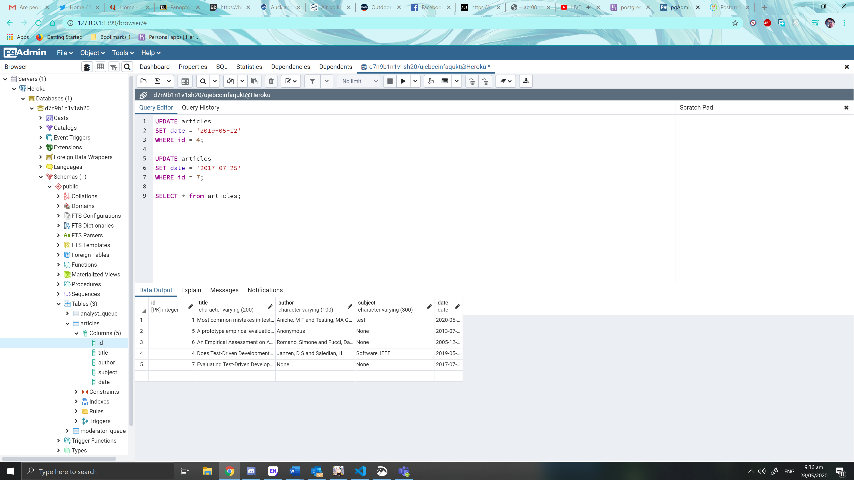

Added a date column using pgadmin

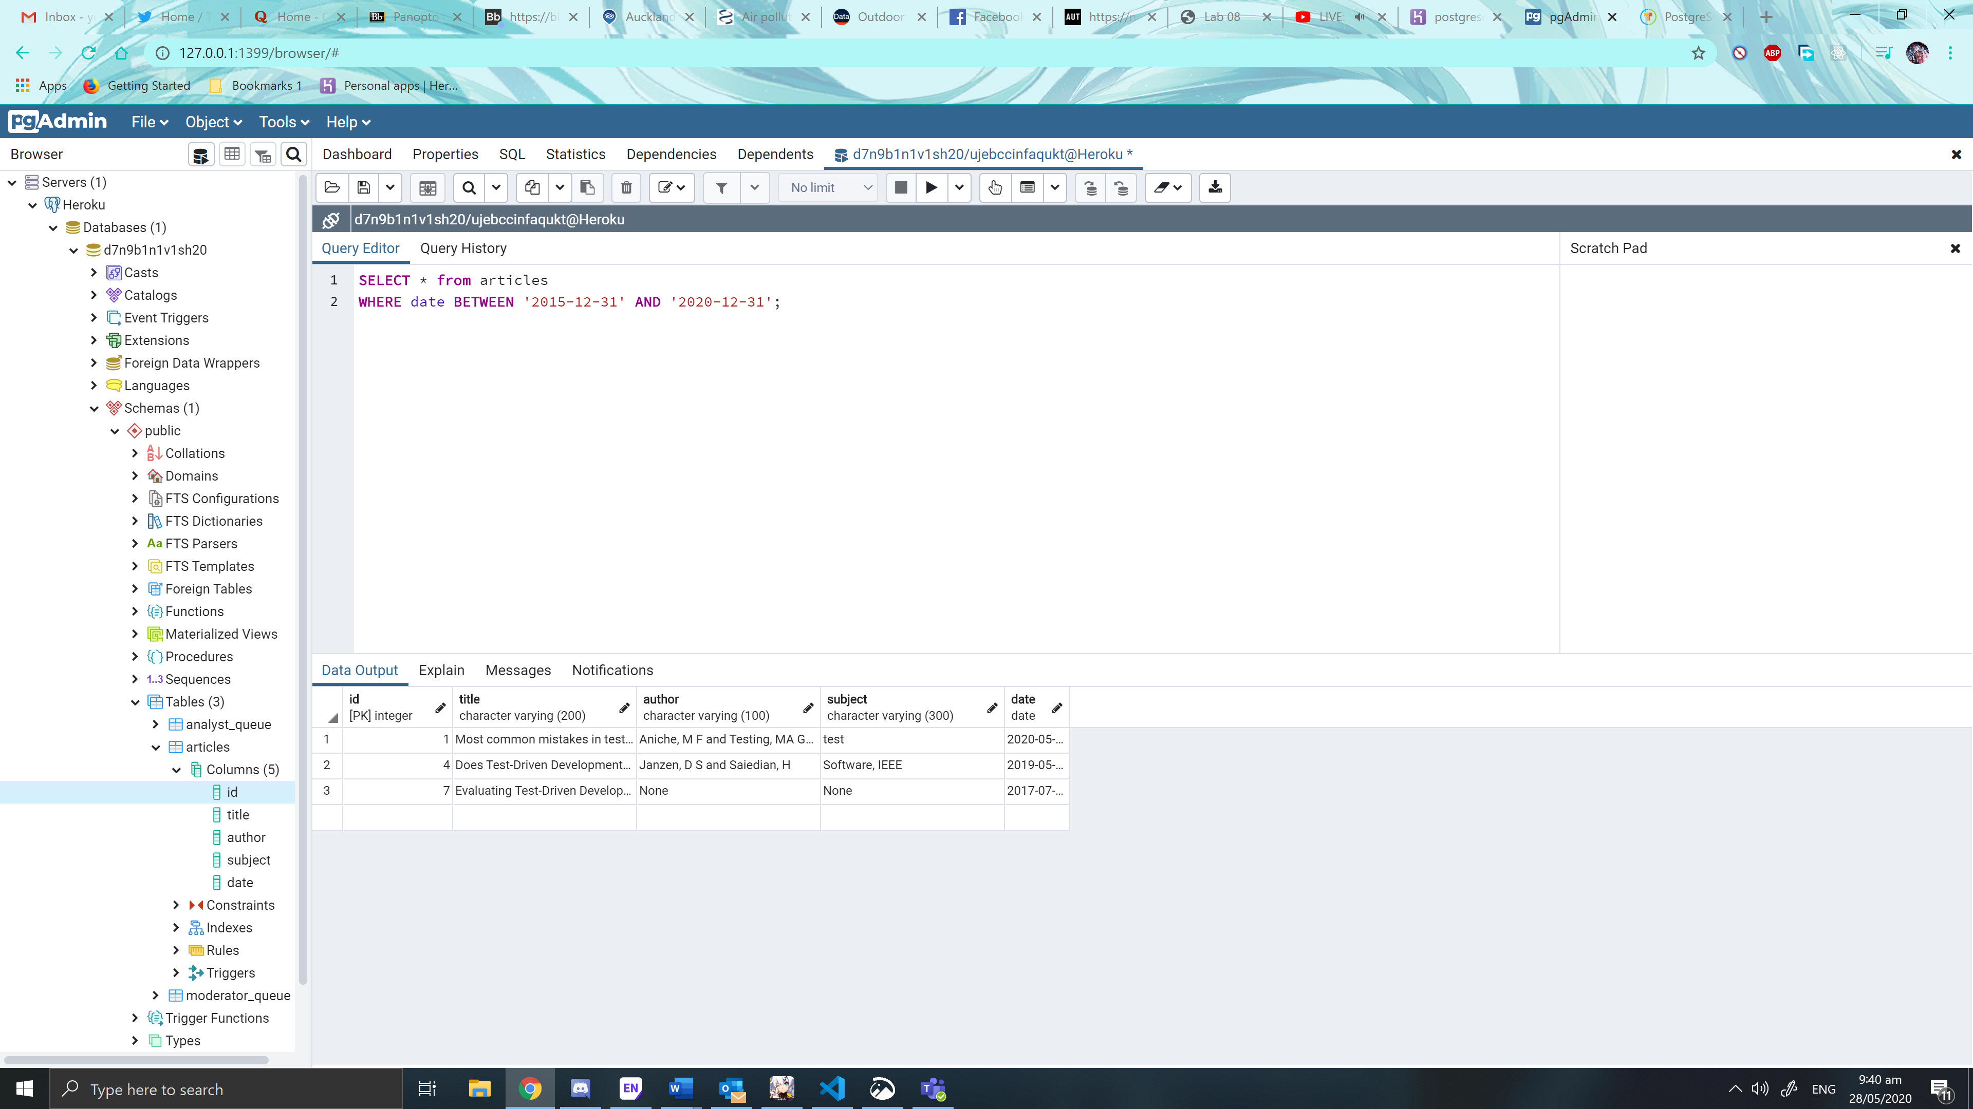

Added date between ranges. Now to implement in SEER search

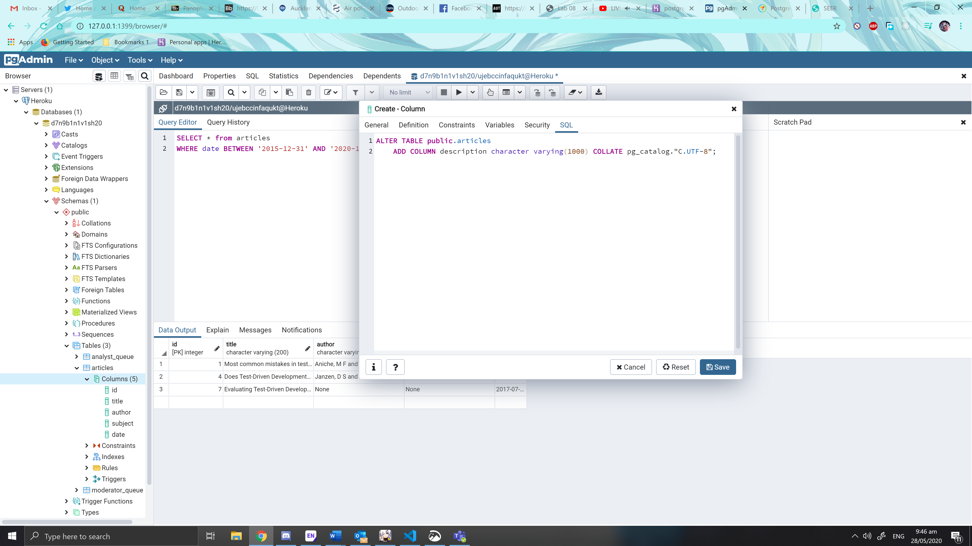

Creating a description column

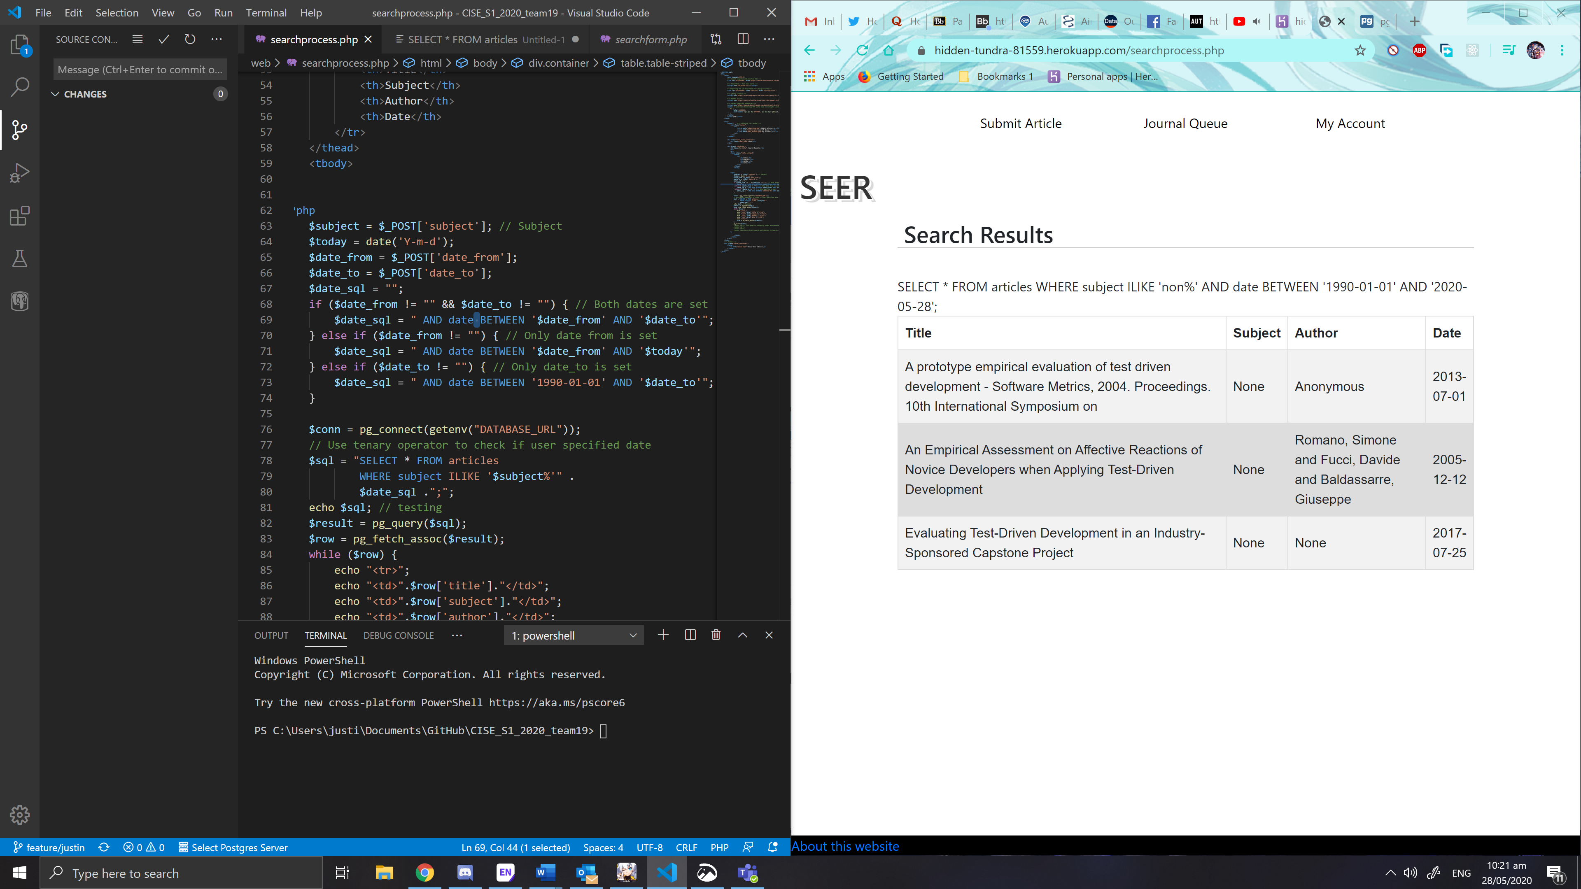Made date ranges work for all situations, eg. The date from is not filled out, it will use the year 1990 as the date from. It will also display all rows if dates are not specified

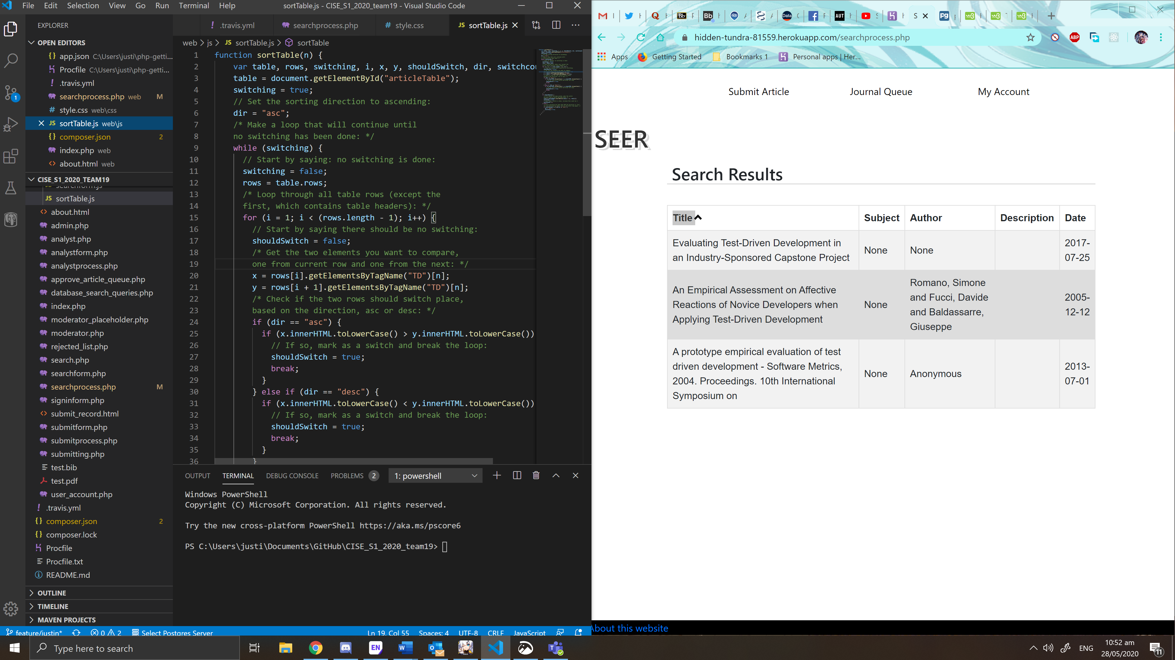Made sorting table work using javascript and using arrows on the table

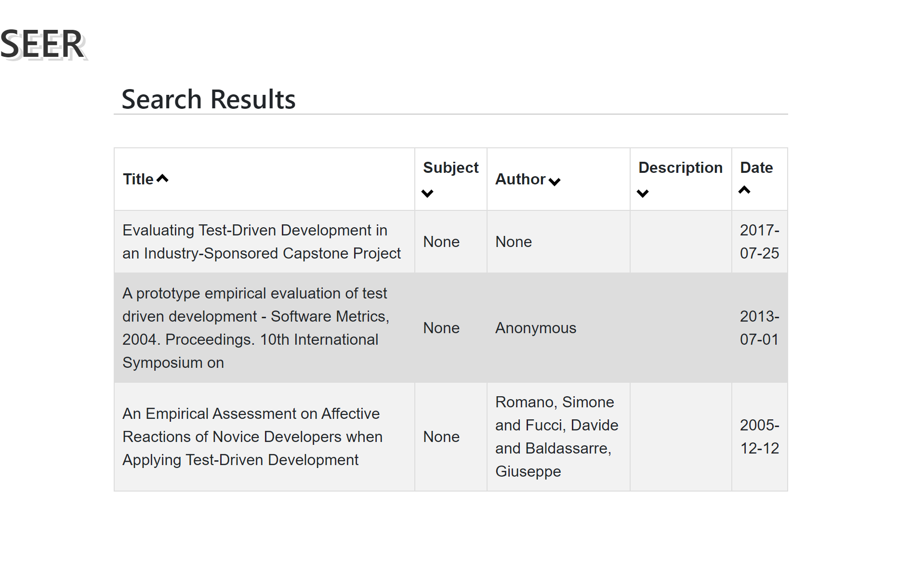

Inserted arrows that you can click to sort. The order of the table is dependent on the direction of the arrows

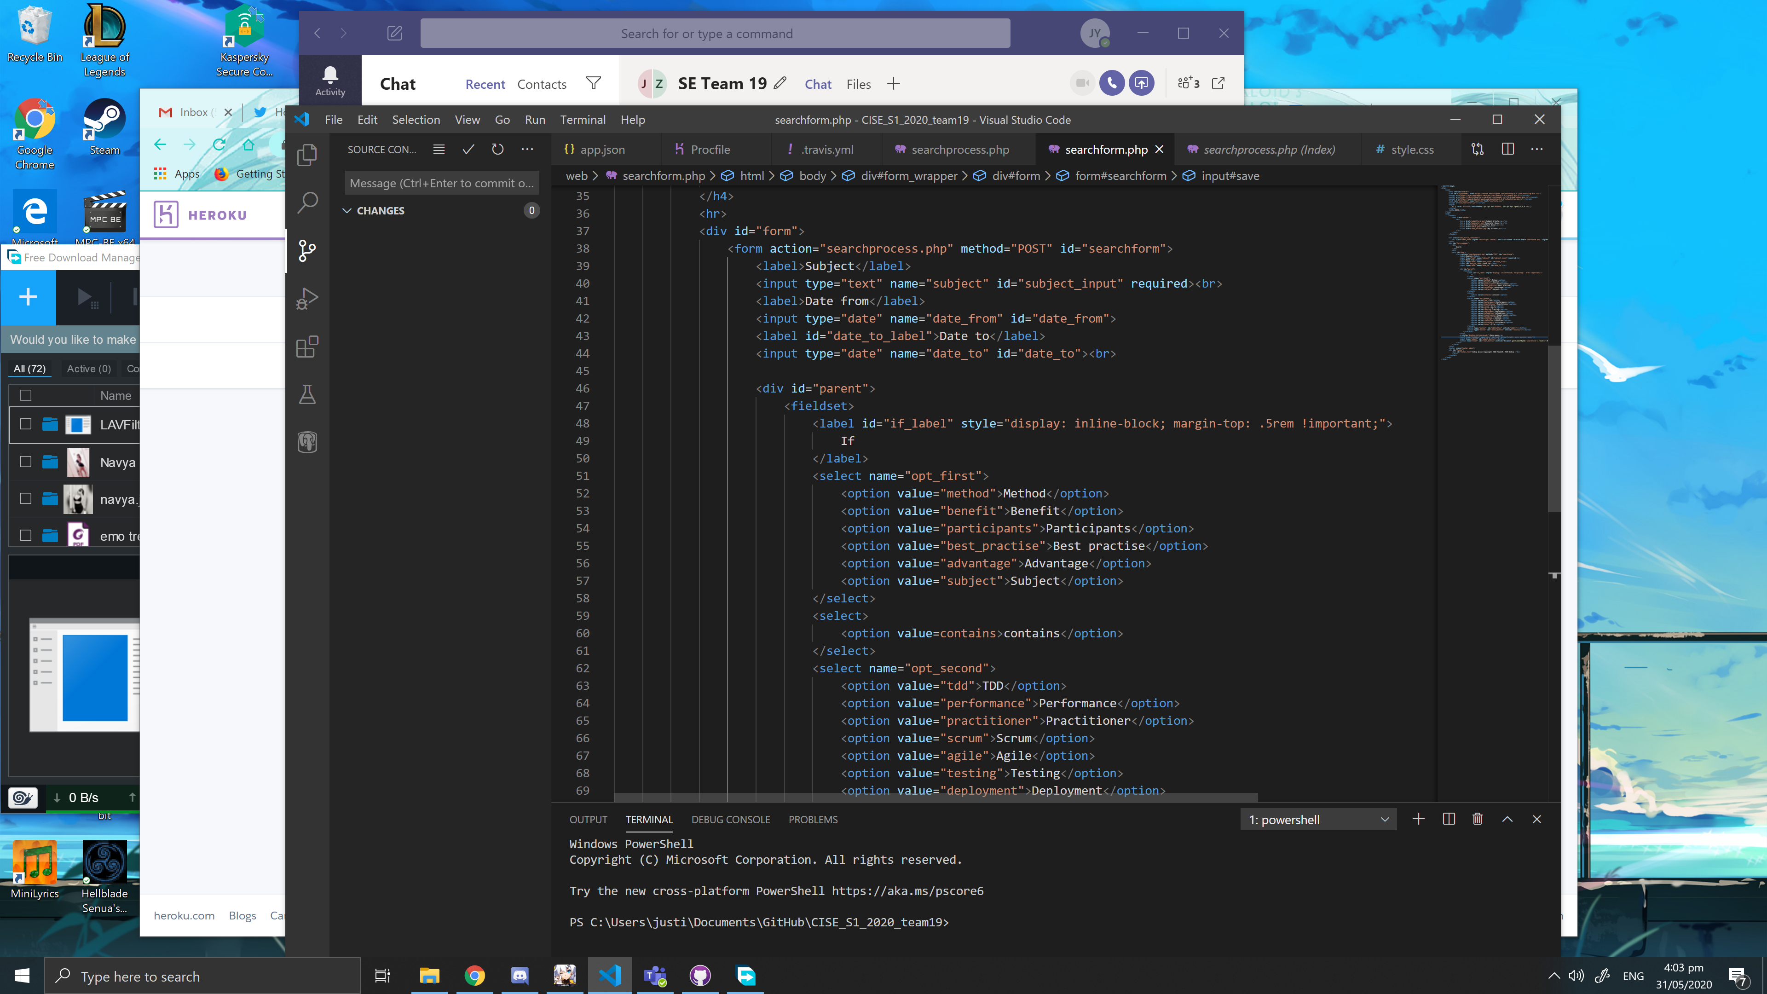

I had to fix some sql queries and form tags because after merging the develop branch to my branch, a few of my changes got lost. Also, I made the reset button clear the form and submit button submit the form. There still appearance improvements needed.

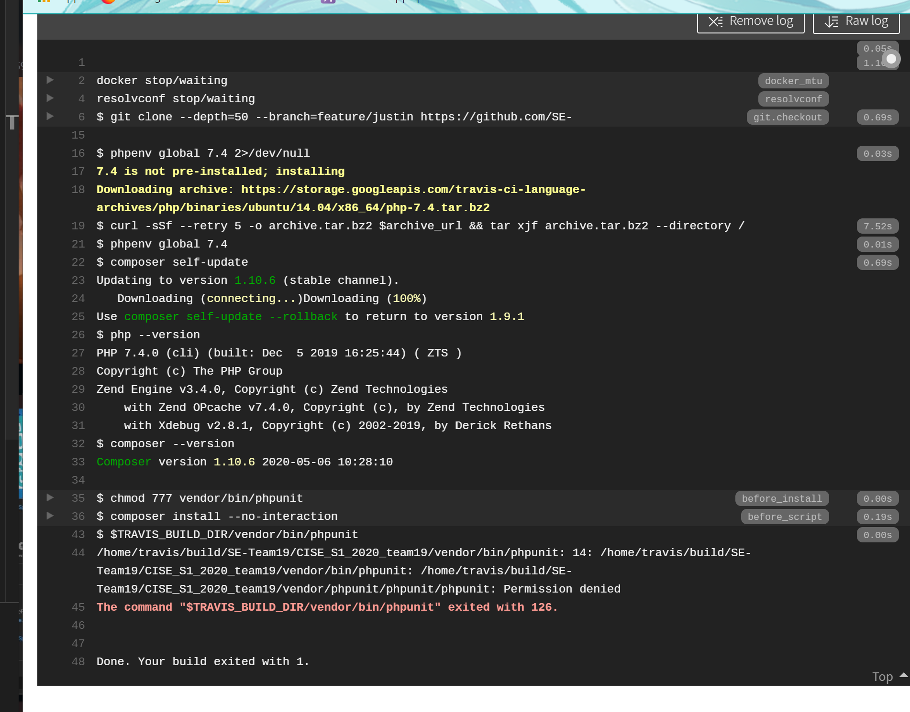

TravisCI will still return permission denied even if I set execute permissions in the phpunit. I have tried everything to get it work including reinstalling phpunit with composer on Git Bash but no avail.

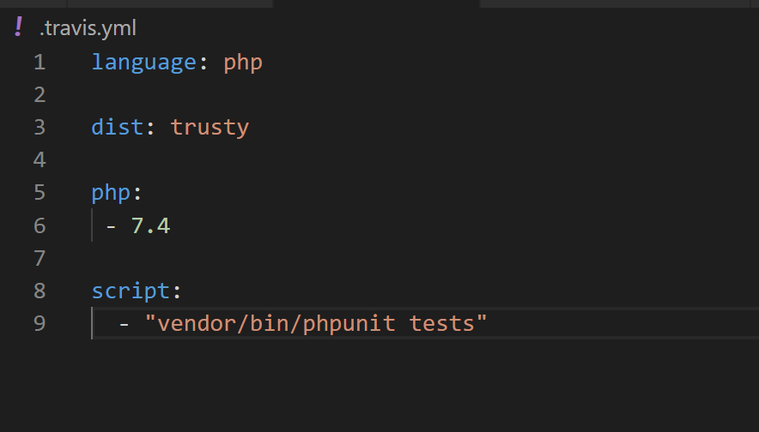

Looks like it’s working now after I removed the before install scripts

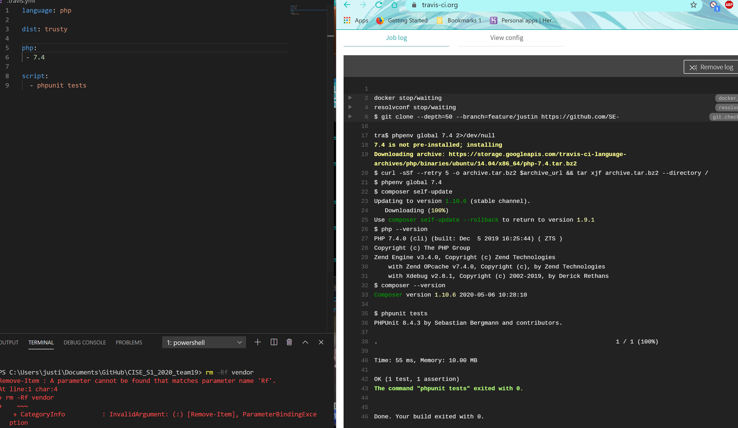

I have successfully made TravisCI work by updating the script line, just the phpunit tests is fine.

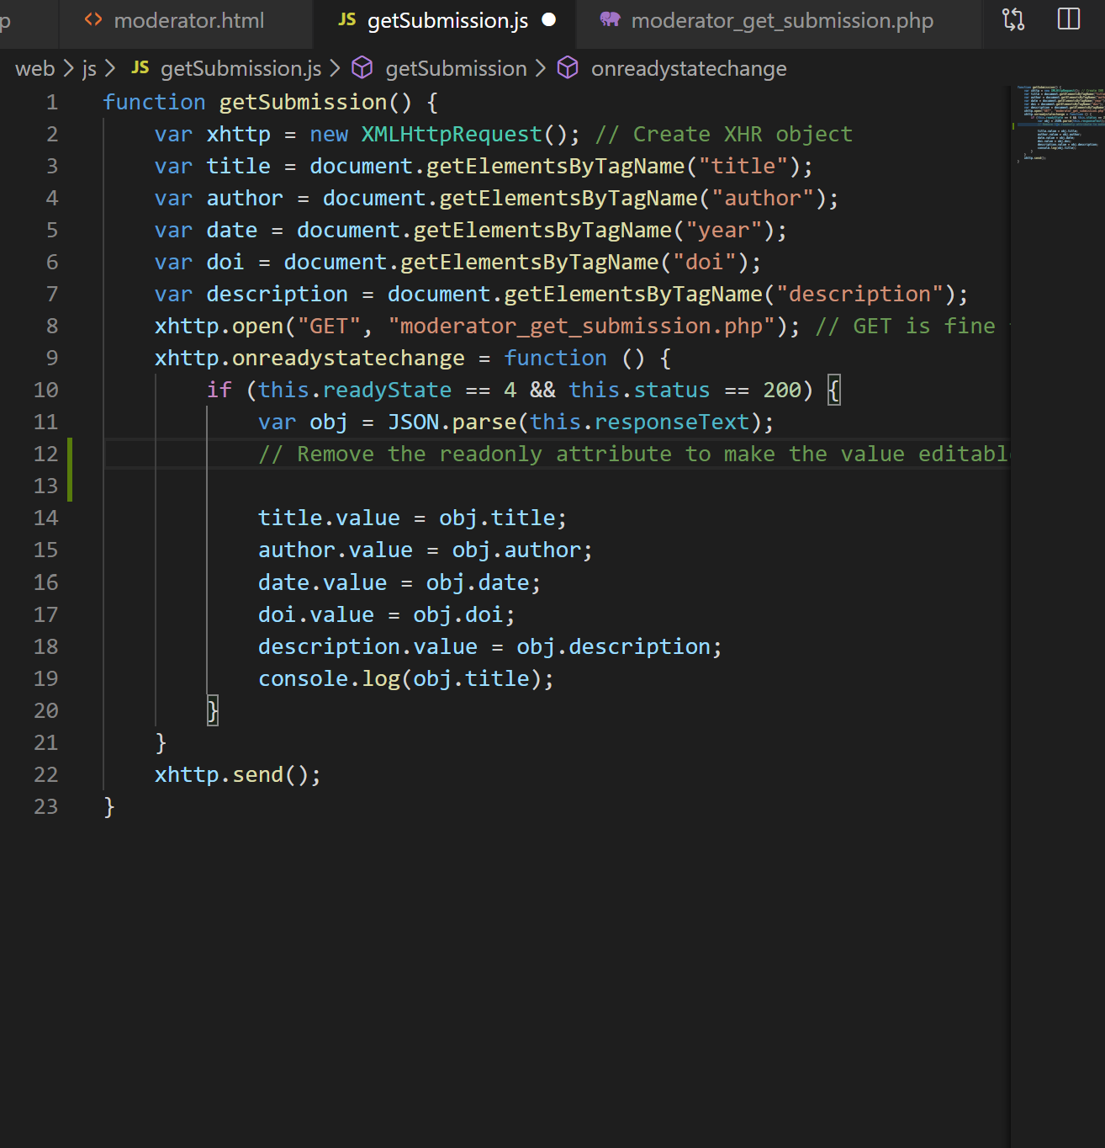

Working on moderator page. I’m using AJAX XHR object to send the requests to PHP so that the page does not have to refresh or be sent to another page. The response from PHP is encoded via JSON for easy handling of data. The input text fields are readonly so I need to remove them first, insert the bibliographic details, then add the readonly attribute back.

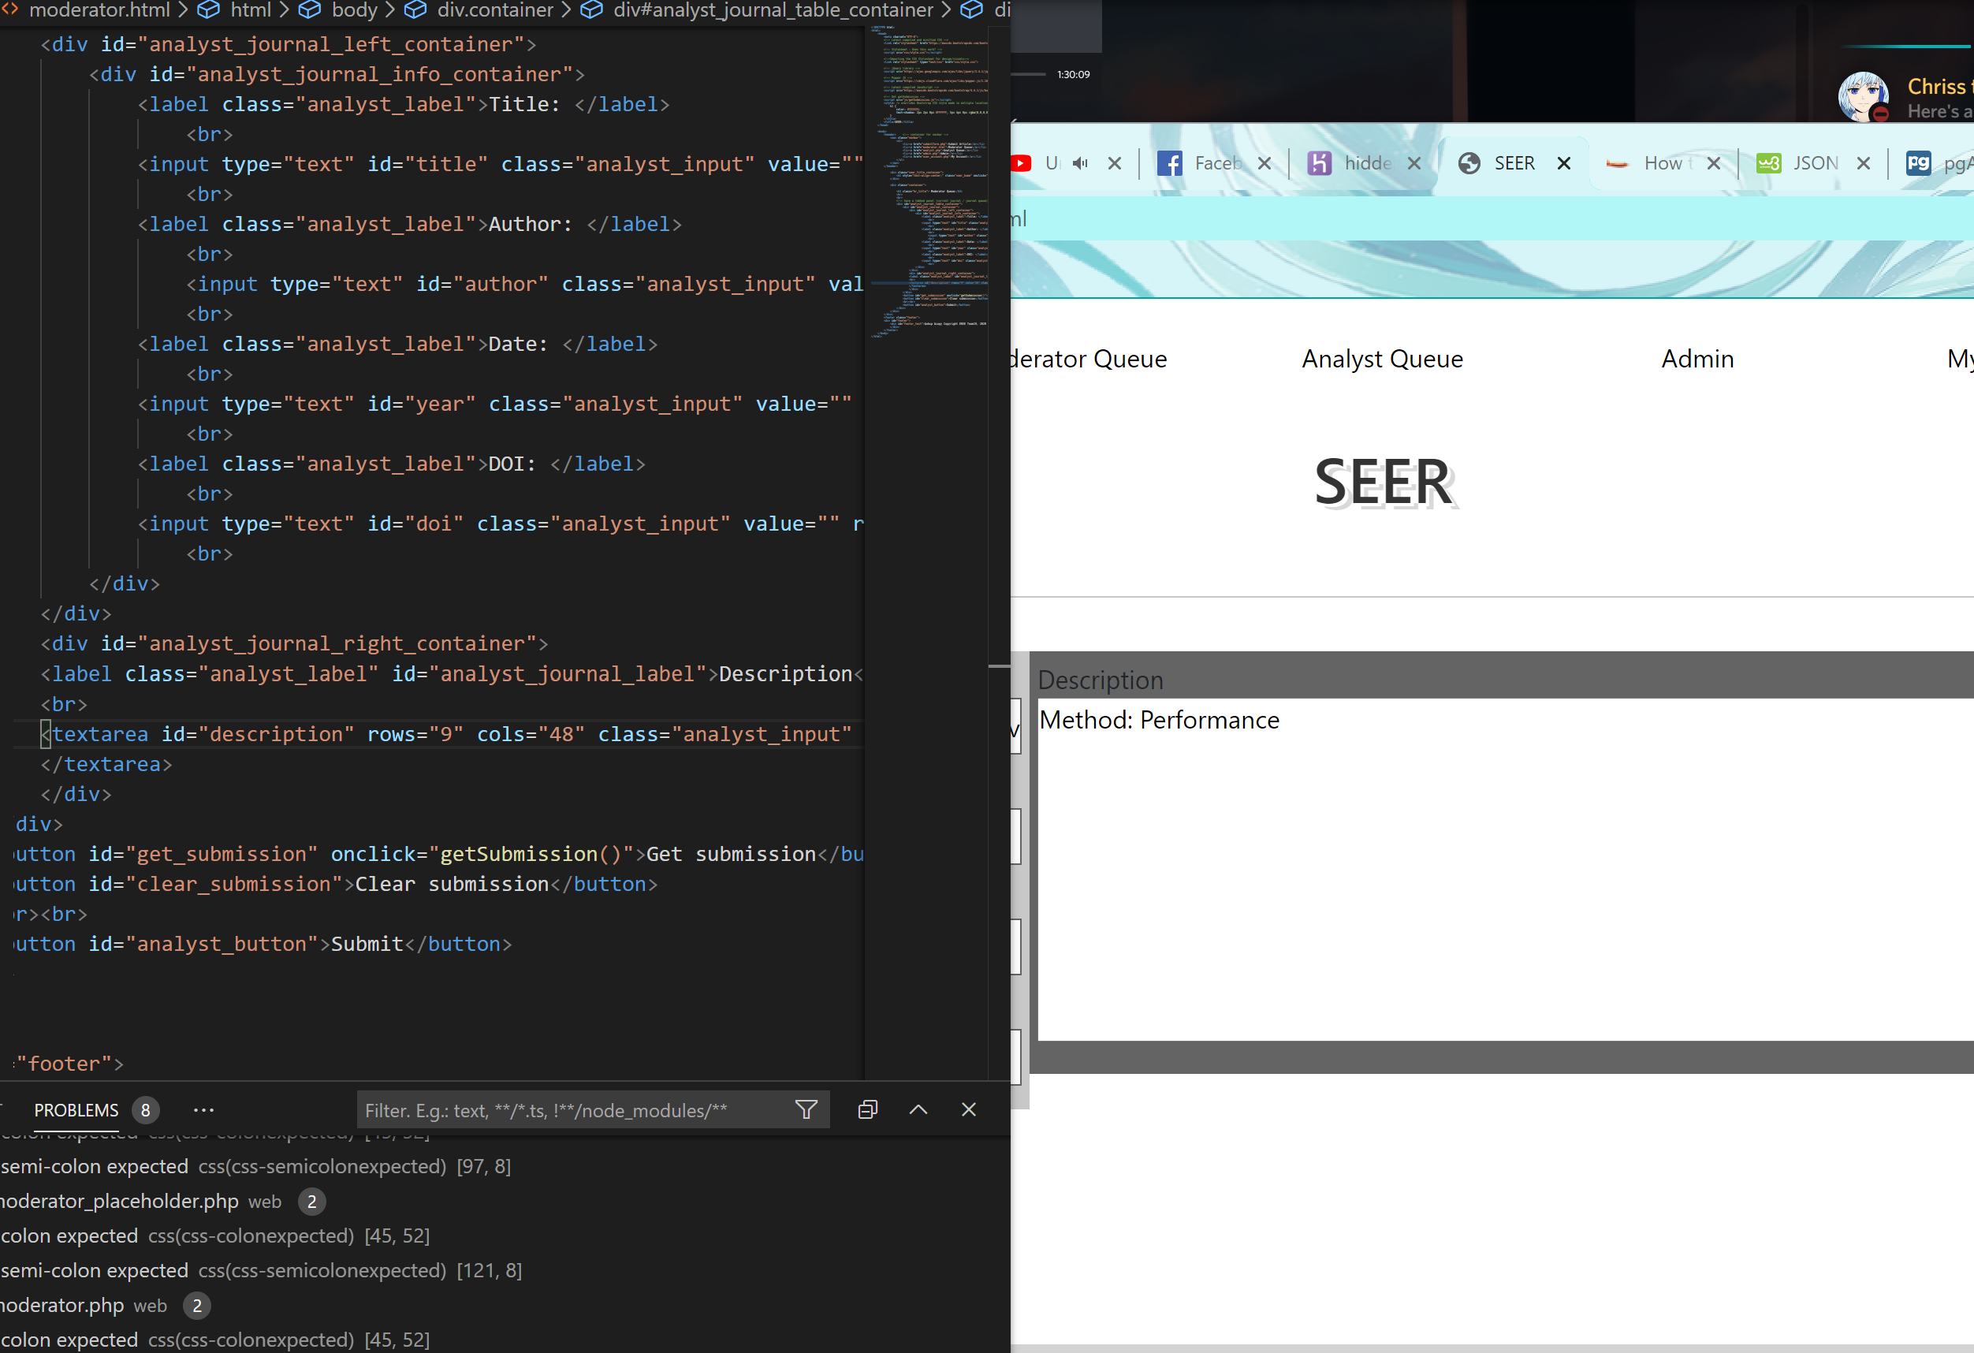

Looks like removing attribute wasn’t needed. But I had to change those attributes from name to id so I can use the DOM function of getElementByID.

## **Task Distribution**

*Contents of Evidence Log:*

|  |  |  |
| --- | --- | --- |
|  | **Description** | **Assigned** |
|  | Photo or screen shot of the story board at least at the start and of each week. Describe any changes and the product backlog order and info on user story cards. | **Zane** |
|  | Photos/documents showing Definition of Done (DoD), | **James** |
|  | Sprint goals for each sprint (1 sentence - related to the high level feature you will deliver) | **James** |
|  | A Team agreement, NO TEAM ROLES. | **Justin** |
|  | Photos/audio/video of the sprint planning at the start of each sprint including planning poker | **Justin** |
|  | Photos of the burndown chart at the start and end of each sprint | **James** |
|  | Photos of whiteboard drawings or documents showing how the design of the product has changed | **Zane** |
|  | Photos/audio/video of face-to-face and screen shots of electronic **daily (or frequent) planning** meetings (like stand-up meetings - answering 3 questions)  Tuesday Thursday Sunday 7:30pm | **James** |
|  | Photos/videos of setting up and use of tools - screen shots, configuration files, instructions. This includes IDEs or text editors, Git/GitHub, TravisCI, web frameworks, testing framework, Heroku, cloud deployment tools, Docker, Slack, electronic story board, bug management software etc.... | **Zane** |
|  | Photos or pdf files showing any product mockups and feedback and changes. | **James** |
|  | Photos/audio/video of sprint reviews (one per sprint) and a discussion of learning and changes from a product perspective | **Zane** |
|  | Photos/documents of the results of doing acceptance tests | **Justin** |
|  | Photos/audio/video of doing retrospectives (one in sprint 1 and one in sprint 2) including a list of NEW things to try in the next sprint and why and how you will know if they are better. | **Justin** |
|  | Photos/audio/video of any other meetings | **Zane** |
|  | Photos of meetings and emails/Slack correspondence with the PO. | **Justin** |

## **5. Sprint Planning**